Tutorial 9 – Black-Box & White-Box Testing
Screenshot Report
Field | Details
Website / Tool | OrangeHRM Demo (black box, integration, system) + Python program (white box)
URL | https://opensource-demo.orangehrmlive.com
Module | Login, Dashboard, Employee Management
Student Task | Execute black-box, integration and system test cases on OrangeHRM and document white-box coverage for a small Python program.
Test Cases | Same TC IDs as the test case sheet: BB01 to WB03
Tester Name | Tester: Kothari Mann Jitendrakumar
Enrollment No | 2504030100433
Environment | Windows 10/11, Google Chrome (latest), internet connection

Black Box Testing

BB01 – Verify valid login
TC ID | BB01
Test Case | Verify valid login
Test Data | Admin / admin123
Expected Result | User logs in and the Dashboard opens
Actual Result | Dashboard opened
Status | PASS
Screenshot | 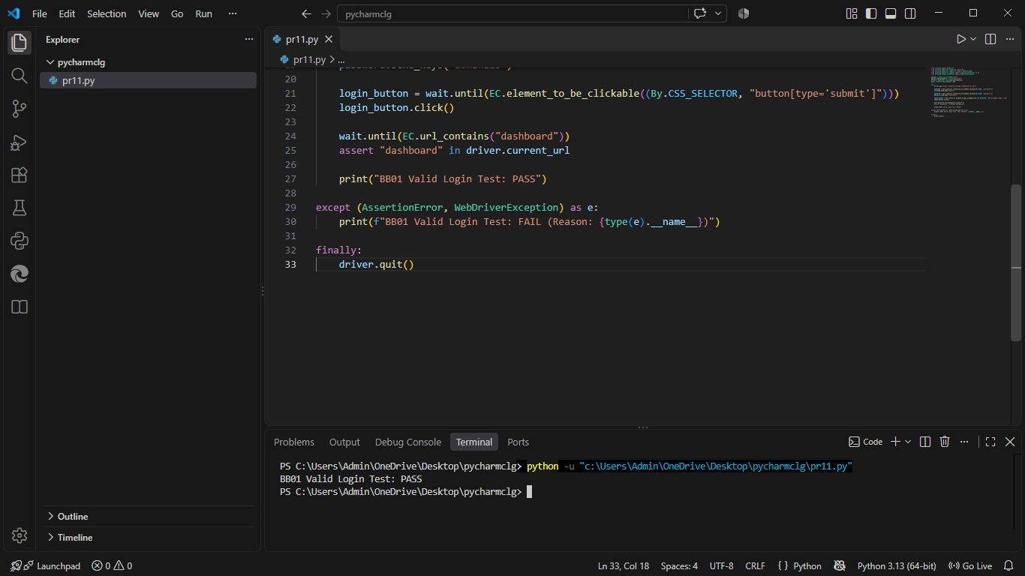
Defect ID | N/A

BB02 – Verify invalid login
TC ID | BB02
Test Case | Verify invalid login
Test Data | Admin / wrong123
Expected Result | Error 'Invalid credentials' is displayed
Actual Result | 'Invalid credentials' displayed
Status | PASS
Screenshot | 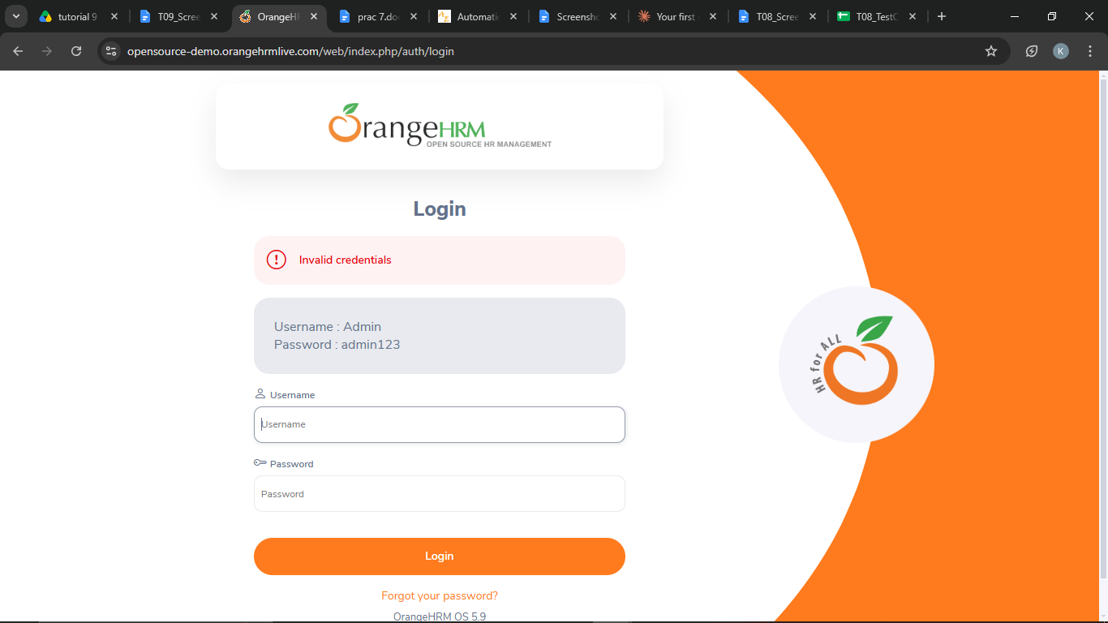
Defect ID | N/A

BB03 – Verify blank login
TC ID | BB03
Test Case | Verify blank login
Test Data | (blank) / (blank)
Expected Result | 'Required' message is shown under both fields
Actual Result | 'Required' shown under both fields
Status | PASS
Screenshot | 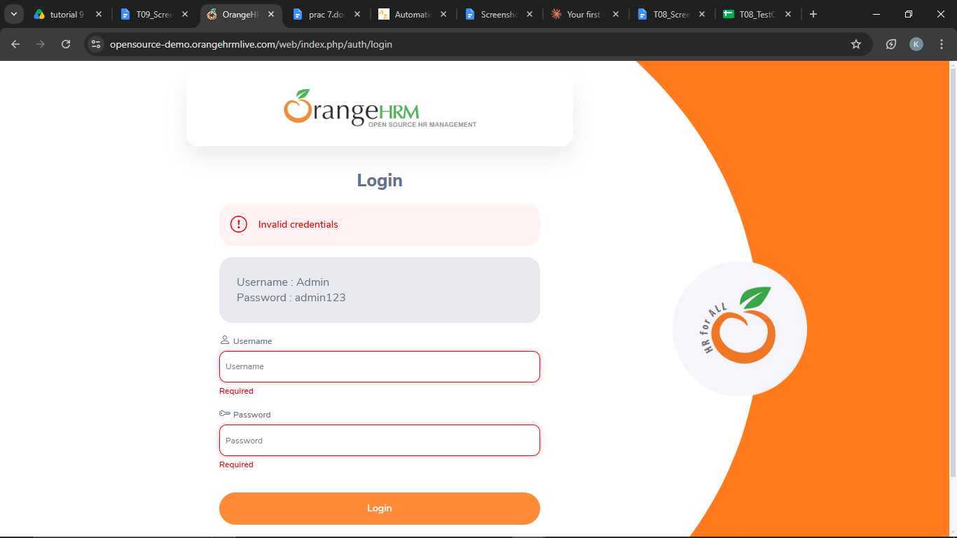
Defect ID | N/A

Integration Testing

INT01 – Verify Login -> Dashboard
TC ID | INT01
Test Case | Verify Login -> Dashboard
Test Data | Admin / admin123
Expected Result | Dashboard opens after successful login
Actual Result | Dashboard opened
Status | PASS
Screenshot | 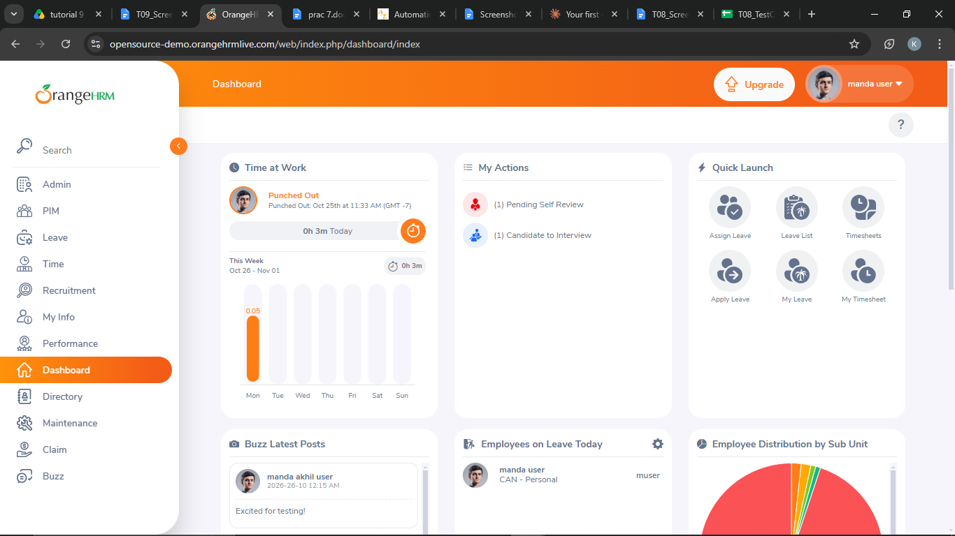
Defect ID | N/A

INT02 – Verify Dashboard -> Employee Management (PIM)
TC ID | INT02
Test Case | Verify Dashboard -> Employee Management (PIM)
Test Data | -
Expected Result | Employee Information (employee list) page opens
Actual Result | PIM page opened
Status | PASS
Screenshot | 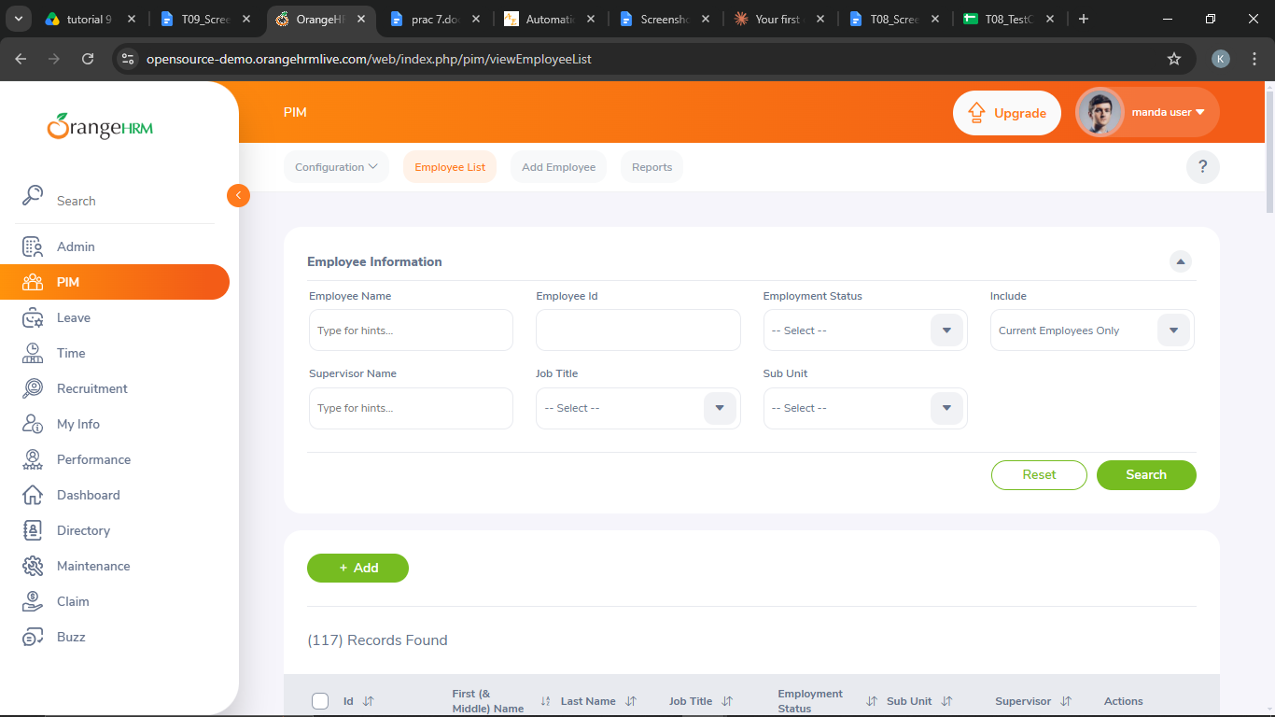
Defect ID | N/A

System Testing

SYS01 – Verify the complete workflow
TC ID | SYS01
Test Case | Verify the complete workflow
Test Data | Employee name: Test Student<number>
Expected Result | Employee is added, found in the list and logout returns to the login page
Actual Result | Employee added and found; logout successful
Status | PASS
Screenshot | 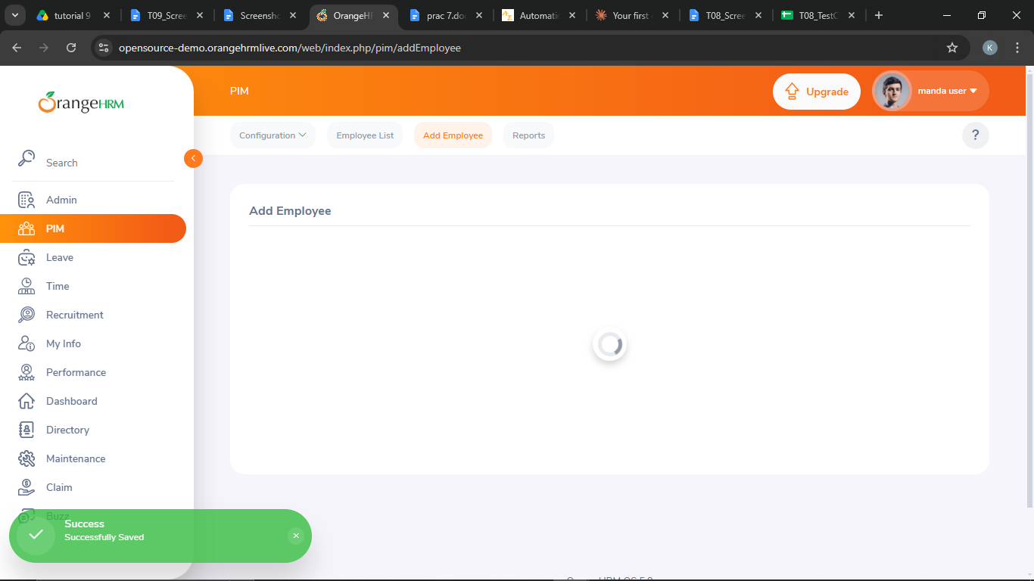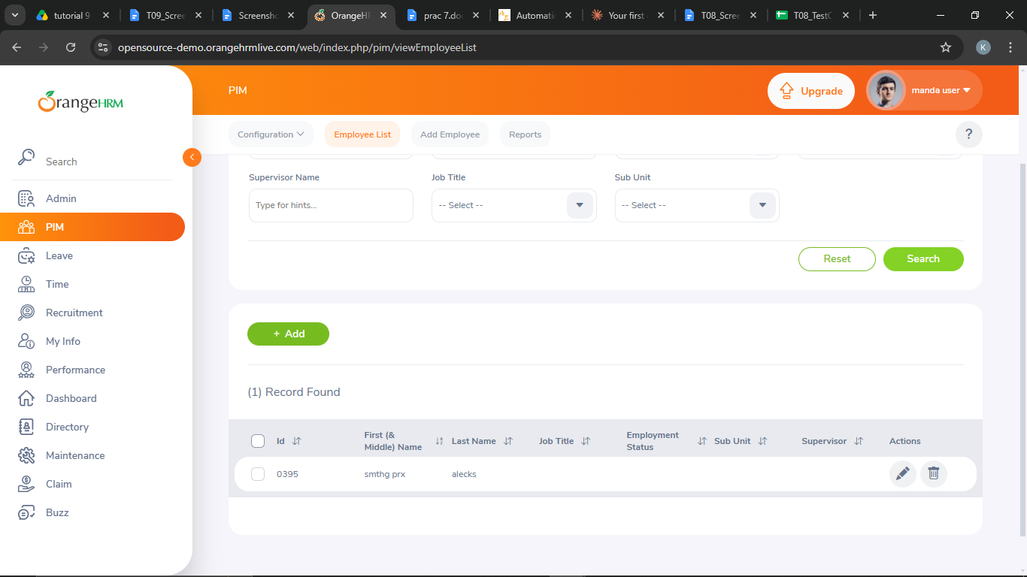
Defect ID | N/A

White Box Testing
Program under test (save as login.py and run it with the inputs of WB01 to WB03):
username = input("Enter Username: ")
password = input("Enter Password: ")
if username == "admin" and password == "admin123":
print("Login Successful")
print("Dashboard Opened")
else:
print("Invalid Username or Password")

Measured by running the program (statement coverage counts lines 1,2,3,4,5,7):
[WB01] input: admin / admin123 output: Login Successful | Dashboard Opened
lines executed: [1, 2, 3, 4, 5] statement coverage: 5/6
[WB02] input: admin / 12345 output: Invalid Username or Password
lines executed: [1, 2, 3, 7] statement coverage: 4/6
[WB03] input: student / admin123 output: Invalid Username or Password
lines executed: [1, 2, 3, 7] statement coverage: 4/6

WB01 – Verify if-branch (valid credentials) of the Python program
TC ID | WB01
Test Case | Verify if-branch (valid credentials) of the Python program
Test Data | admin / admin123
Expected Result | Branch executed: 'Login Successful' and 'Dashboard Opened' printed
Actual Result | Login Successful, Dashboard Opened (5/6 statements covered)
Status | PASS
Screenshot | 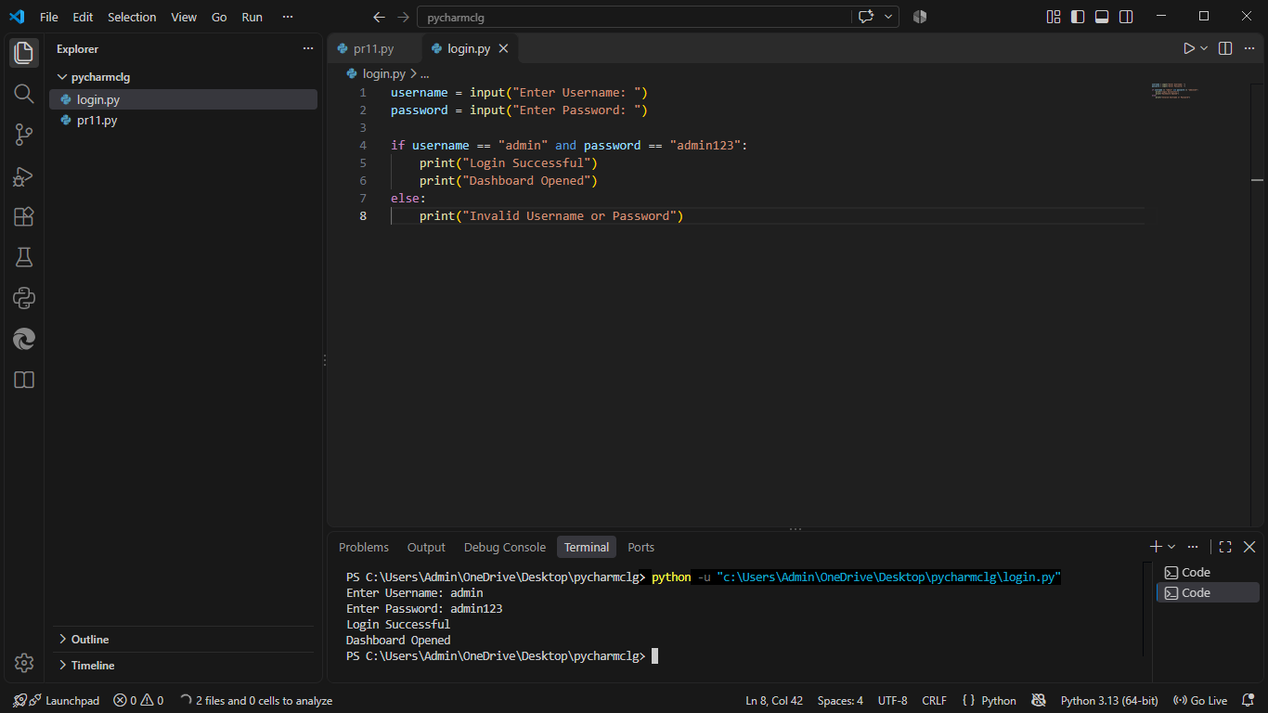
Defect ID | N/A

WB02 – Verify else-branch (wrong password)
TC ID | WB02
Test Case | Verify else-branch (wrong password)
Test Data | admin / 12345
Expected Result | Branch executed: 'Invalid Username or Password' printed
Actual Result | Invalid Username or Password (4/6 statements covered)
Status | PASS
Screenshot | 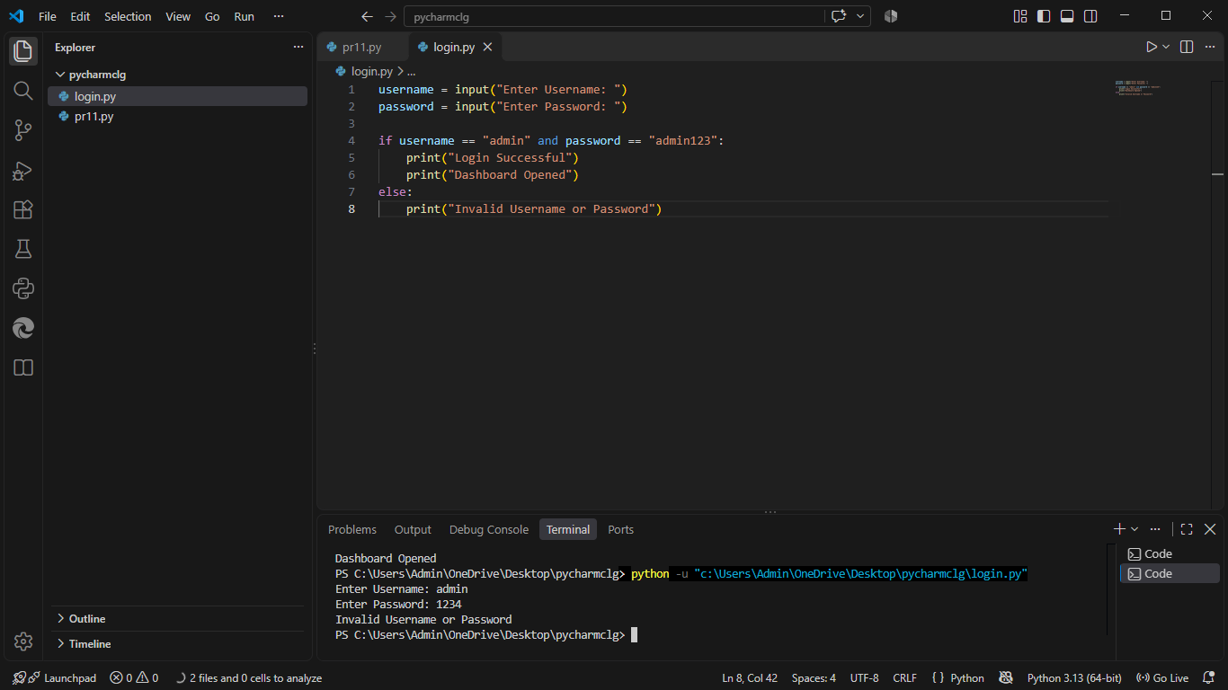
Defect ID | N/A

WB03 – Verify else-branch (wrong username)
TC ID | WB03
Test Case | Verify else-branch (wrong username)
Test Data | student / admin123
Expected Result | Branch executed: 'Invalid Username or Password' printed
Actual Result | Invalid Username or Password (4/6 statements covered)
Status | PASS
Screenshot | 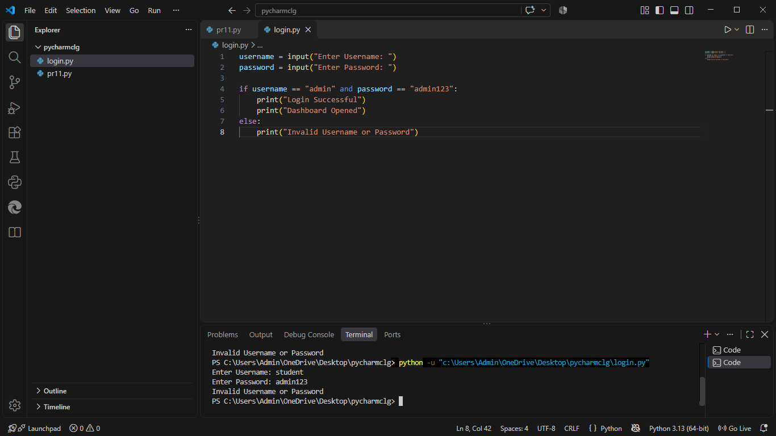
Defect ID | N/A

White-Box Coverage (login.py) - measured by running the program
Test | Input | Lines executed | Statement coverage | Branch taken
WB01 | admin / admin123 | [1, 2, 3, 4, 5] | 5/6 | if (True)
WB02 | admin / 12345 | [1, 2, 3, 7] | 4/6 | else (False)
WB03 | student / admin123 | [1, 2, 3, 7] | 4/6 | else (False)
All | WB01 + WB02 + WB03 | [1, 2, 3, 4, 5, 7] | 6/6 = 100% | 2/2 branches = 100%

Path Coverage
Path | Condition outcome | Result | Covered by
1 | username != admin | Invalid Username or Password | WB03
2 | username == admin and password != admin123 | Invalid Username or Password | WB02
3 | username == admin and password == admin123 | Login Successful + Dashboard Opened | WB01

Test Execution Summary
Metric | Value
Total Test Cases | 9
Passed | 9
Failed | 0
Blocked | 0
Not executed yet (fill after running) | 0
Pass % | 100.0%

